FRIDAY, September 16, 2016 AT 6 P.M.
Classes: Entry Fee: $10.00

WCR Indicates Washington Co. Residents Only Classes

1. Stick Horse (No Entry Fee – Ribbon Only)
2. Western Halter Mares & Geldings
3. Best Groomed Horse/Pony
4. Open Halter (All Breeds, All Ages, All Exhibitors)
5. Lead Line (No Entry Fee – Ribbons Only)
6. WCR Go As You Please (All Breeds, All Ages, Walk & Pleasure Gait)
7. WCR Juvenile Country Pleasure (Exhibitor 17 Yrs. &
Under, Flat Shod or Lite Shod, No Bands, 2 Gaits)
8. WCR Costume Class (Exhibitor 18 Yrs. & Under)
9. WCR Juvenile Western Pleasure (Ex.17 Yrs. & Under)
10. WCR Ladies Country Pleasure (Flat Shod or Lite Shod,
No Bands, 2 Gaits)
11. WCR Beginners Western Walk/Jog (Exhibitor 17 Yrs.
& Under; No Cross Entry in any other performance class
except Open Walk/Jog)
12. WCR Men’s Country Pleasure (Exhibitor 18 Yrs. &
Over, Flat Shod or Lite Shod, No Bands, 2 Gaits)
13. WCR Amateur Western Pleasure (Ex.18 Yrs. & over)
14. WCR Open Western Pleasure (Walk, Jog, Lope)
15. Juvenile Country Pleasure (Exhibitor 17 Yrs. & Under,
Flat Shod or Lite Shod, No Bands, 2 Gaits)
16. Go As You Please (All Breeds, All Ages Walk &
Pleasure Gait)
17. Juvenile Western Pleasure (Ex.17 Yrs. & Under, Walk
Jog, Lope)
18. Ladies Country Pleasure (Flat shod or Lite Shod,
No Bands, 2 Gaits)
19. Western Beginners Walk/Jog (Ex.17 Yrs. & Under; No
Cross Entry in any other performance class except Open
Walk/Jog)
20. Men’s Country Pleasure (Ex.18 Yrs. & Over, Flat shod or
Lite Shod, No Bands, 2 Gaits)
21. Jack Benny/Lucille Ball (Rider 39 Yrs. & Over, any
Breed, Walk & Gait of Choice)
22. Open Beginners Western Pleasure (Walk, Jog, Only,
No Lope)
23. Open Country Pleasure (Flat shod or Lite Shod,
No Bands, 2 Gaits)
24. Open Western Pleasure (W/J/L) *See Rules On Back*
25. Open Pacing
26. WCR Open Pole Bending***
27. Open Pole Bending***
28. WCR Juvenile Barrel Race (Ex. 18 yrs. & Under) ***
29. Juvenile Barrel Race (Ex 18 yrs. & Under) ***
30. WCR Open Barrel Race (All ages) ***
31. Open Barrels***

Long Sleeves REQUIRED in ALL classes
SATURDAY, September 17, 2016 AT 10 A.M.
Classes: Entry Fee: $10.00
3-D Barrels: $25.00
_______________________________________
- Amateur Showmanship at Halter (Exhibitor 19
Years & Over; English or Western)
- Showmanship at Halter (Exhibitor 18 yrs. & Under)
- 4-H Showmanship at Halter (English, Western or
Hunt Seat)
- Miniature Horse Halter (38” & Under)
- Western Halter Mares
- Best Groomed Horse (Any Breed, Exhibitor 17 &
Under)
- Open Paint Horse Halter – The "How 'bout That!" Memorial Perpetual Challenge Trophy
- Western Halter Stallions & Geldings (All Ages
Exhibitor & All Ages of horses)
- Best Groomed Pony (Any Breeds, Exhibitor 17 &
Under)
- Open Arabian Halter
- Open Halter (All Exhibitors, All Breeds, All Ages)

******************Break******************
- Lead Line (No Entry Fee – Ribbons Only)
- Adult Go As You Please (Walk, & Gait of Choice)
- Open High Point Western Pleasure (All Breeds; Walk, Jog & Lope) Trophy Class
***See Rules On Back***
- Mule Go As You Please (Walk & Gait of Choice)
- Youth English Pleasure (Exhibitor 12 & Under;
No Cross Entry, Walk, Trot, No Canter)
- 4-H Western Pleasure (Walk and Jog Only,
4-H Members Only)
- Pony Go As You Please (Ponies 58”, Any
Breed- 2 Gaits - Walk and Trot or Slow Gait, English or
Western, Riders ages 10 and Under)
- Open Country Pleasure (Flat Shod, Bands
Allowed, No Canter, 2 Gaits)
- Juvenile Western Pleasure (Exhibitors 18 &
Under; Walk, Jog and Lope)
- Arabian Native Costume
- Ladies Country Racking (Flat Shod, Bands
Allowed)
- Costume Class (Exhibitor 18 & Under)
- Ladies Country Pleasure (Flat Shod, Bands
Allowed, No Canter, 2 Gaits)
- Beginner Western Walk/Jog (Walk and Jog Only,
No Lope)
- Youth English Pleasure (Exhibitor 13 to 18 yrs.; No
Cross Entry, Walk & Trot, No Canter)
- Juvenile Country Pleasure (Exhibitor 17 & Under,
Flat Shod, Bands Allowed, 2 Gaits)
- Amateur Western Pleasure (Exhibitor 19 & Over,
Walk, Jog, Lope)
- Juvenile Go As You Please (Exhibitor 13 to
18 yrs. old, Any Breed - Walk & Gait of Choice,
English or Western)
- Men’s Country Pleasure (Flat Shod, Bands
Allowed, No Canter, 2 Gaits)
- 4-H English Pleasure (4-H Members Only,
Hunter or Saddle Seat)
- Juvenile Go As You Please (Exhibitor 12 &
Under, Any Breed - Walk and Gait of Choice,
English or Western)
- Juvenile Hunter Saddle (Exhibitor 18 & Under;
Walk, Trot, Canter)
- Arabian English Pleasure (Walk, Trot, Canter)
- Juvenile Ambling Country Pleasure
(Exhibitor 17 & Under, Flat or Lite Shod, No Bands,
2 Gaits)
- Liberty (Arabians, Half-Arabians & Anglo-Arabians)

******************Break******************
- Stick Horse (No Entry Fee – Ribbon Only)
- Open Driving
- Open Hunter Under Saddle (Walk, Trot, Canter,
All Breeds)
- Jack Benny/Lucille Ball Class (Riders 39 &
Over, Any Breed, 2 Gaits, Walk & Pleasure Gait)
- Beginner Hunter Under Saddle – Walk/Trot
(No Cross Entry, Walk and Trot, No Canter)
- Youth English Pleasure (Exhibitor 17 & Under,
Walk, Trot, Canter; Saddle Seat or Hunter)
- Open Ambling Country Pleasure (Flat Shod,
No Bands, No Canter, 2 Gaits; Juveniles, Men’s & Ladies Combined)
- Open English–Saddle Seat (Walk & Trot Only,
No Canter)
- Juvenile Trail Racking (Walk & Trail Racking)
- Arabian Hunter Pleasure
- Men’s Country Racking (Flat Shod, Bands
Allowed)
- Open Road Ponies
- Hunter Under Saddle (Walk, Trot, Canter, Stock
Type, Only)
50. Ladies Ambling Country Pleasure (Flat Shod
No Bands, No Canter, 2 Gaits)
51. Trail Racking (Light Shod)
52. Racking Country Pleasure (Show Walk, Slow
Rack, Fast Rack)
53. Ladies Trail Racking (Walk & Trail Racking)
54. Men’s Ambling Country Pleasure (Flat Shod,
No Bands, No Canter, 2 Gaits)
55. Arabian Western Pleasure (Walk, Jog, Lope)
56. Open Pacing

******************Break******************
SPEED EVENTS WILL NOT START BEFORE 6:00 P.M.
***Long Sleeves required in ALL speed events***

* Exhibitors to START & STOP inside the arena*
Per Insurance Requirements

- Exhibition Barrels ($5.00/Run, Exhibition Only)
- Youth Barrel Race (Exhibitor 12 & Under)
- Juvenile Barrel Race (Exhibitor 13 to 18 Yrs.)
- Ladies Barrel Race
- Men’s Barrel Race
- Open Potato Race
- Speed Race
- Rescue Race
- Juvenile Poles (Exhibitor 18 & Under)
- Open Pole Bending
- 3-D Barrels (must have shown in a qualifying class
either Friday Night Speed Events or Saturday Speed
Events)

Breaks will be announced and be
at Judges Discretion.

Exhibitors please be ready at the gate when your classes are called. There will be a 2-minute gate call on classes.

* The Judge’s decision is final *

Payback for Classes

Entry Fee for most Classes: $10.00

Payback Friday: 20 15 10

Payback Saturday: 30 20 10

Stick Horse & Lead Line
No entry fee, Ribbons Only

3-D Barrels
Entry Fee: $25.00
with added money
Must Qualify
Qualifying Classes:
Classes 26-31 Friday Night
Classes 61-69 Saturday Night

~~~~ RULES ~~~~

CURRENT 12 MONTH NEGATIVE COGGINS TEST is required prior to entering the Show Ground and must be presented at the gate and at the Office upon entry. No Entry to the Show Grounds without the Negative Coggins

~ This show Washington County Horse Show Classics, is operated in accordance with the current rules of the Mid South Horse Show Association (MSHSA)

~ Juveniles will not be Allowed to show a stallion in any juvenile class.

~ Stalls are available for $10.00 per stall and will be assigned at the secretary’s booth or you may reserve a stall in advance by calling:
Dianne Andis: 276-628-4900 or 276-492-3475

~ The Washington County Fair Association, the Washington Fairgrounds, any of their volunteers or any of the class sponsors will not be held liable or responsible for any injury to any person, or animal, or for any damage to or loss of personal property on the show grounds and horses are to be exhibited at the risk of the owner or exhibitor.

~ EXHIBITORS ARE REQUIRED TO BE PROPERLY ATTIRED AND KNOW THE RULES FOR YOUR CLASS OR CLASSES.

~ If you show in a Flat Shod, Padded or with Bands class your shoes will need to be certified at the gate prior to your class.

~ In classes that have less than 5 entries,
2nd place money will be paid.

~ The Judge’s decision is final.

~ Gates Open at 4:00 p.m. on Friday

~ Gates open at 8:00 a.m. on Saturday

~ Concessions will be available.

Payback for Classes
Entry Fee: $10.00

Friday Night
Payback: 20 15 10 5

Saturday
Payback: 30 20 10 5

Stick Horse & Lead Line
No entry fee, Ribbons Only

3-D Barrels
Must Qualify
Entry Fee: $25.00
with added money
Qualifying Classes:
Classes 26-31 Friday Night
Classes 61-69 Saturday Night

In classes that have less than 5 entries,
2nd place money will be paid.

This Show is Affiliated with:

Mid South Horse Show Association (MSHSA)
APHA PAC (Paint Alternative Competition)
VPHA (VA Paint Horse Association

Vet on CALL: Washington Co. Vet Service

Like us on FB:
Washington County Horse Show Classics

Email: washcohorseshow@gmail.com

www.washcoclassics.com

Gate Fees:
Ages 13-Adult - $12.00
Ages 6-12 - $2.00
Pre-School - FREE
***NEW THIS YEAR! - 2 TROPHIES***
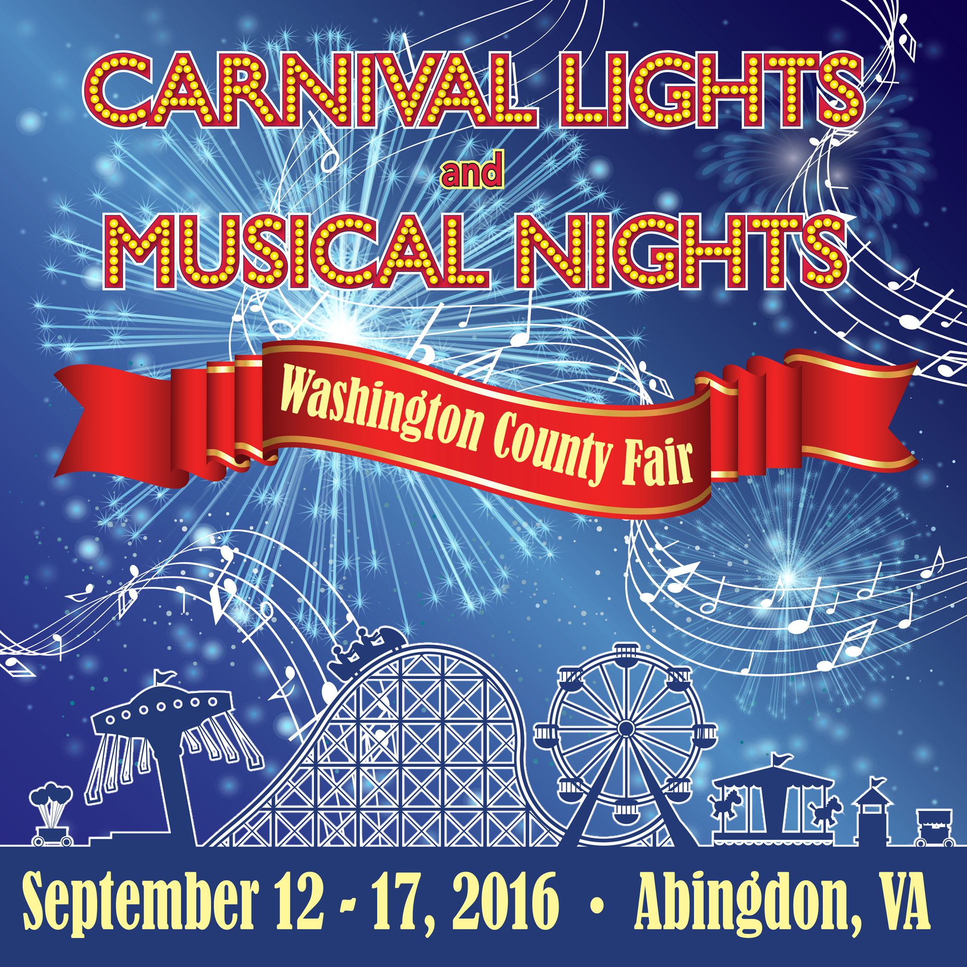
Washington County
Horse Show
Classics

At The Washington County Fair

September 16 & September 17 2016

Washington County, VA Horse Show Grounds

2 NEW Trophy Classes

NEW PAYBACK

Open Classes For All

Juvenile Classes

3-D Barrels

- OPEN HIGH POINT WESTERN PLEASURE TROPHY – Exhibitor Must show in Class 24 Friday Night in Open Western Pleasure & Class 14 Saturday in Open Western Pleasure. Winner will be the Average of the 2-day Placing.

- Open Paint Horse Halter – The "How 'bout That!" Memorial Perpetual Challenge Trophy. This trophy will be awarded to the Winner of Class 7 on Saturday.

2016 Grounds Revitalization Sponsors

Diamond Sponsors: Abingdon Equipment
Berry Home Center
Berry Iron & Metal Co.
Dominion Auto Auction
Dutt & Wagner/Green Valley Farms
Meade Tractor
Virginia Electric Supply
Silver Sponsors: Addington Oil Co.
Farm Credit of the Virginias
Fisher Hollow Veterinary Clinic
Lakeside Ready Mix
Roger’s Trucking, Inc.
Tri-State Veterinary Supply
Washington County Vet Service
Bronze Sponsors: B B & T Bank
The Bank of Abingdon
Eastman Credit Union
First Bank & Trust
First Community Bank
Food City
Forest Management Co., LLC.
Highlands Union Bank
New Peoples Bank
Wythe County Livestock Exchange
Additional Sponsors: Clinch Valley Bank

Are you interested in becoming a Sponsor of
The Washington County Classics?
Ask in the office
Please support our Sponsors and
Thank Them for Sponsoring our Show!

